Aim
To experiment with different layouts and color schemes for a quiz application and collect user feedback on aesthetics and usability using GIMP.

Procedure
Step 1: Create Base Layout
- Open GIMP.
- Click File → New and set dimensions (e.g., 1920 × 1080 px).
- Create different screens:
  - Login Page
  - Quiz Question Page
  - Result Page
Step 2: Design Layout Variations
- Use Rectangle Tool to create containers/cards.
- Add:
  - Text fields (username, password)
  - Buttons (Login, Next, Logout)
- Create multiple layout versions:
  - Centered card layout
  - Split screen layout
  - Minimal layout
Step 3: Apply Color Schemes
- Experiment with different themes:
  - Light theme (white + gray + blue)
  - Dark theme (black + navy + white)
  - Vibrant theme (gradient colors)
- Use Bucket Fill Tool for backgrounds.
- Adjust:
  - Contrast
  - Font color
  - Button highlights
Step 4: Typography & UI Elements
- Use Text Tool to add headings like:
  - “Quiz Login”
  - “Question 1 of 5”
- Apply different fonts and sizes.
- Ensure readability and spacing.
Step 5: Export Designs
- Export each variation:
  - File → Export As → PNG/JPG
- Save multiple versions (Layout A, B, C).
Step 6: Collect User Feedback
- Show designs to 5–10 users.
- Ask questions:
  - Which layout is easier to use?
  - Which color scheme looks better?
  - Is the text readable?
  - Are buttons clearly visible?
- Record responses.
Step 7: Analyze Feedback
- Compare user preferences.
- Identify:
  - Most liked layout
  - Best color scheme
  - Usability issues

Output
- Designed multiple UI screens:
  - Login page with input fields
  - Quiz interface with MCQ options
  - Result page showing score
- Created variations in:
  - Layout (centered, card-based)
  - Colors (light and dark themes)
- Collected feedback showing:
  - Users preferred clean, centered layouts
  - Dark buttons with light background improved visibility
  - Simple UI improved usability
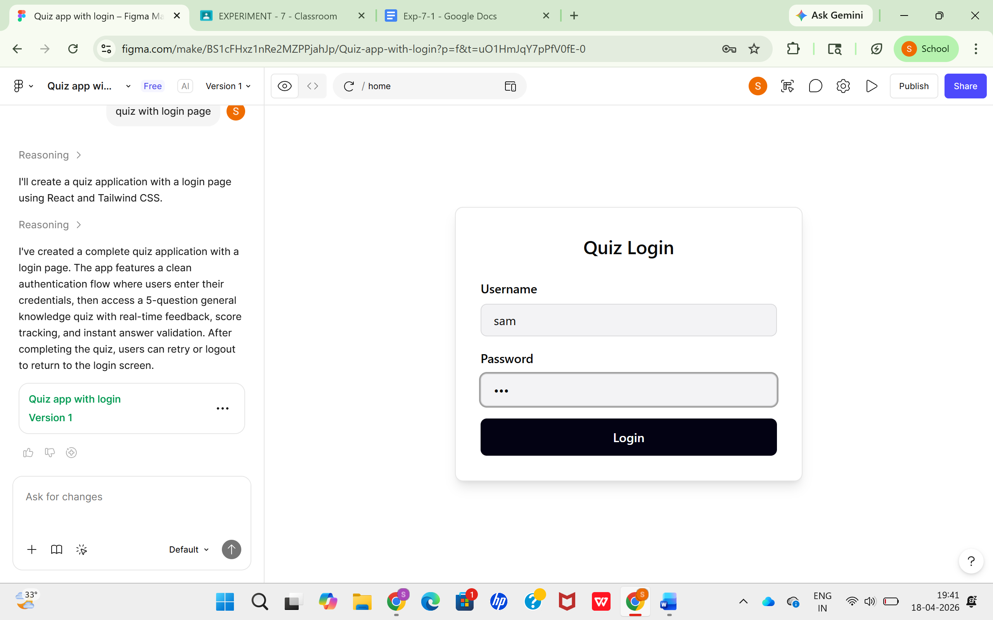

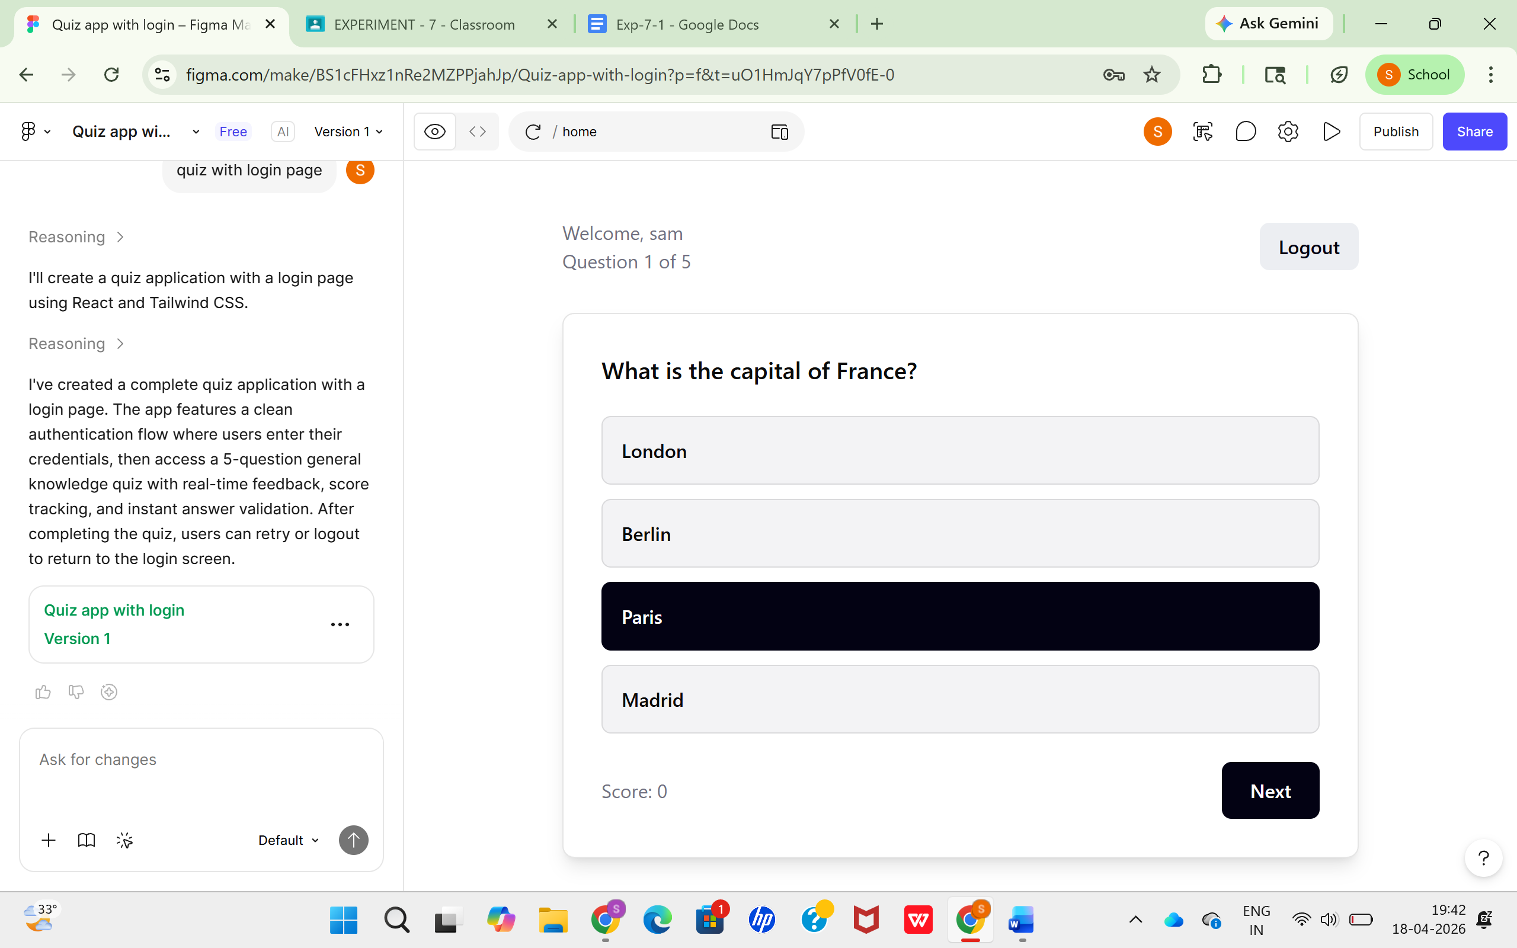

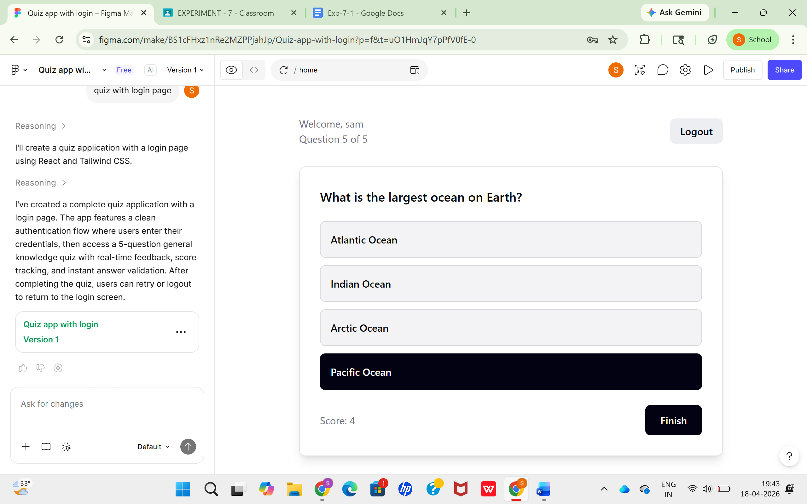

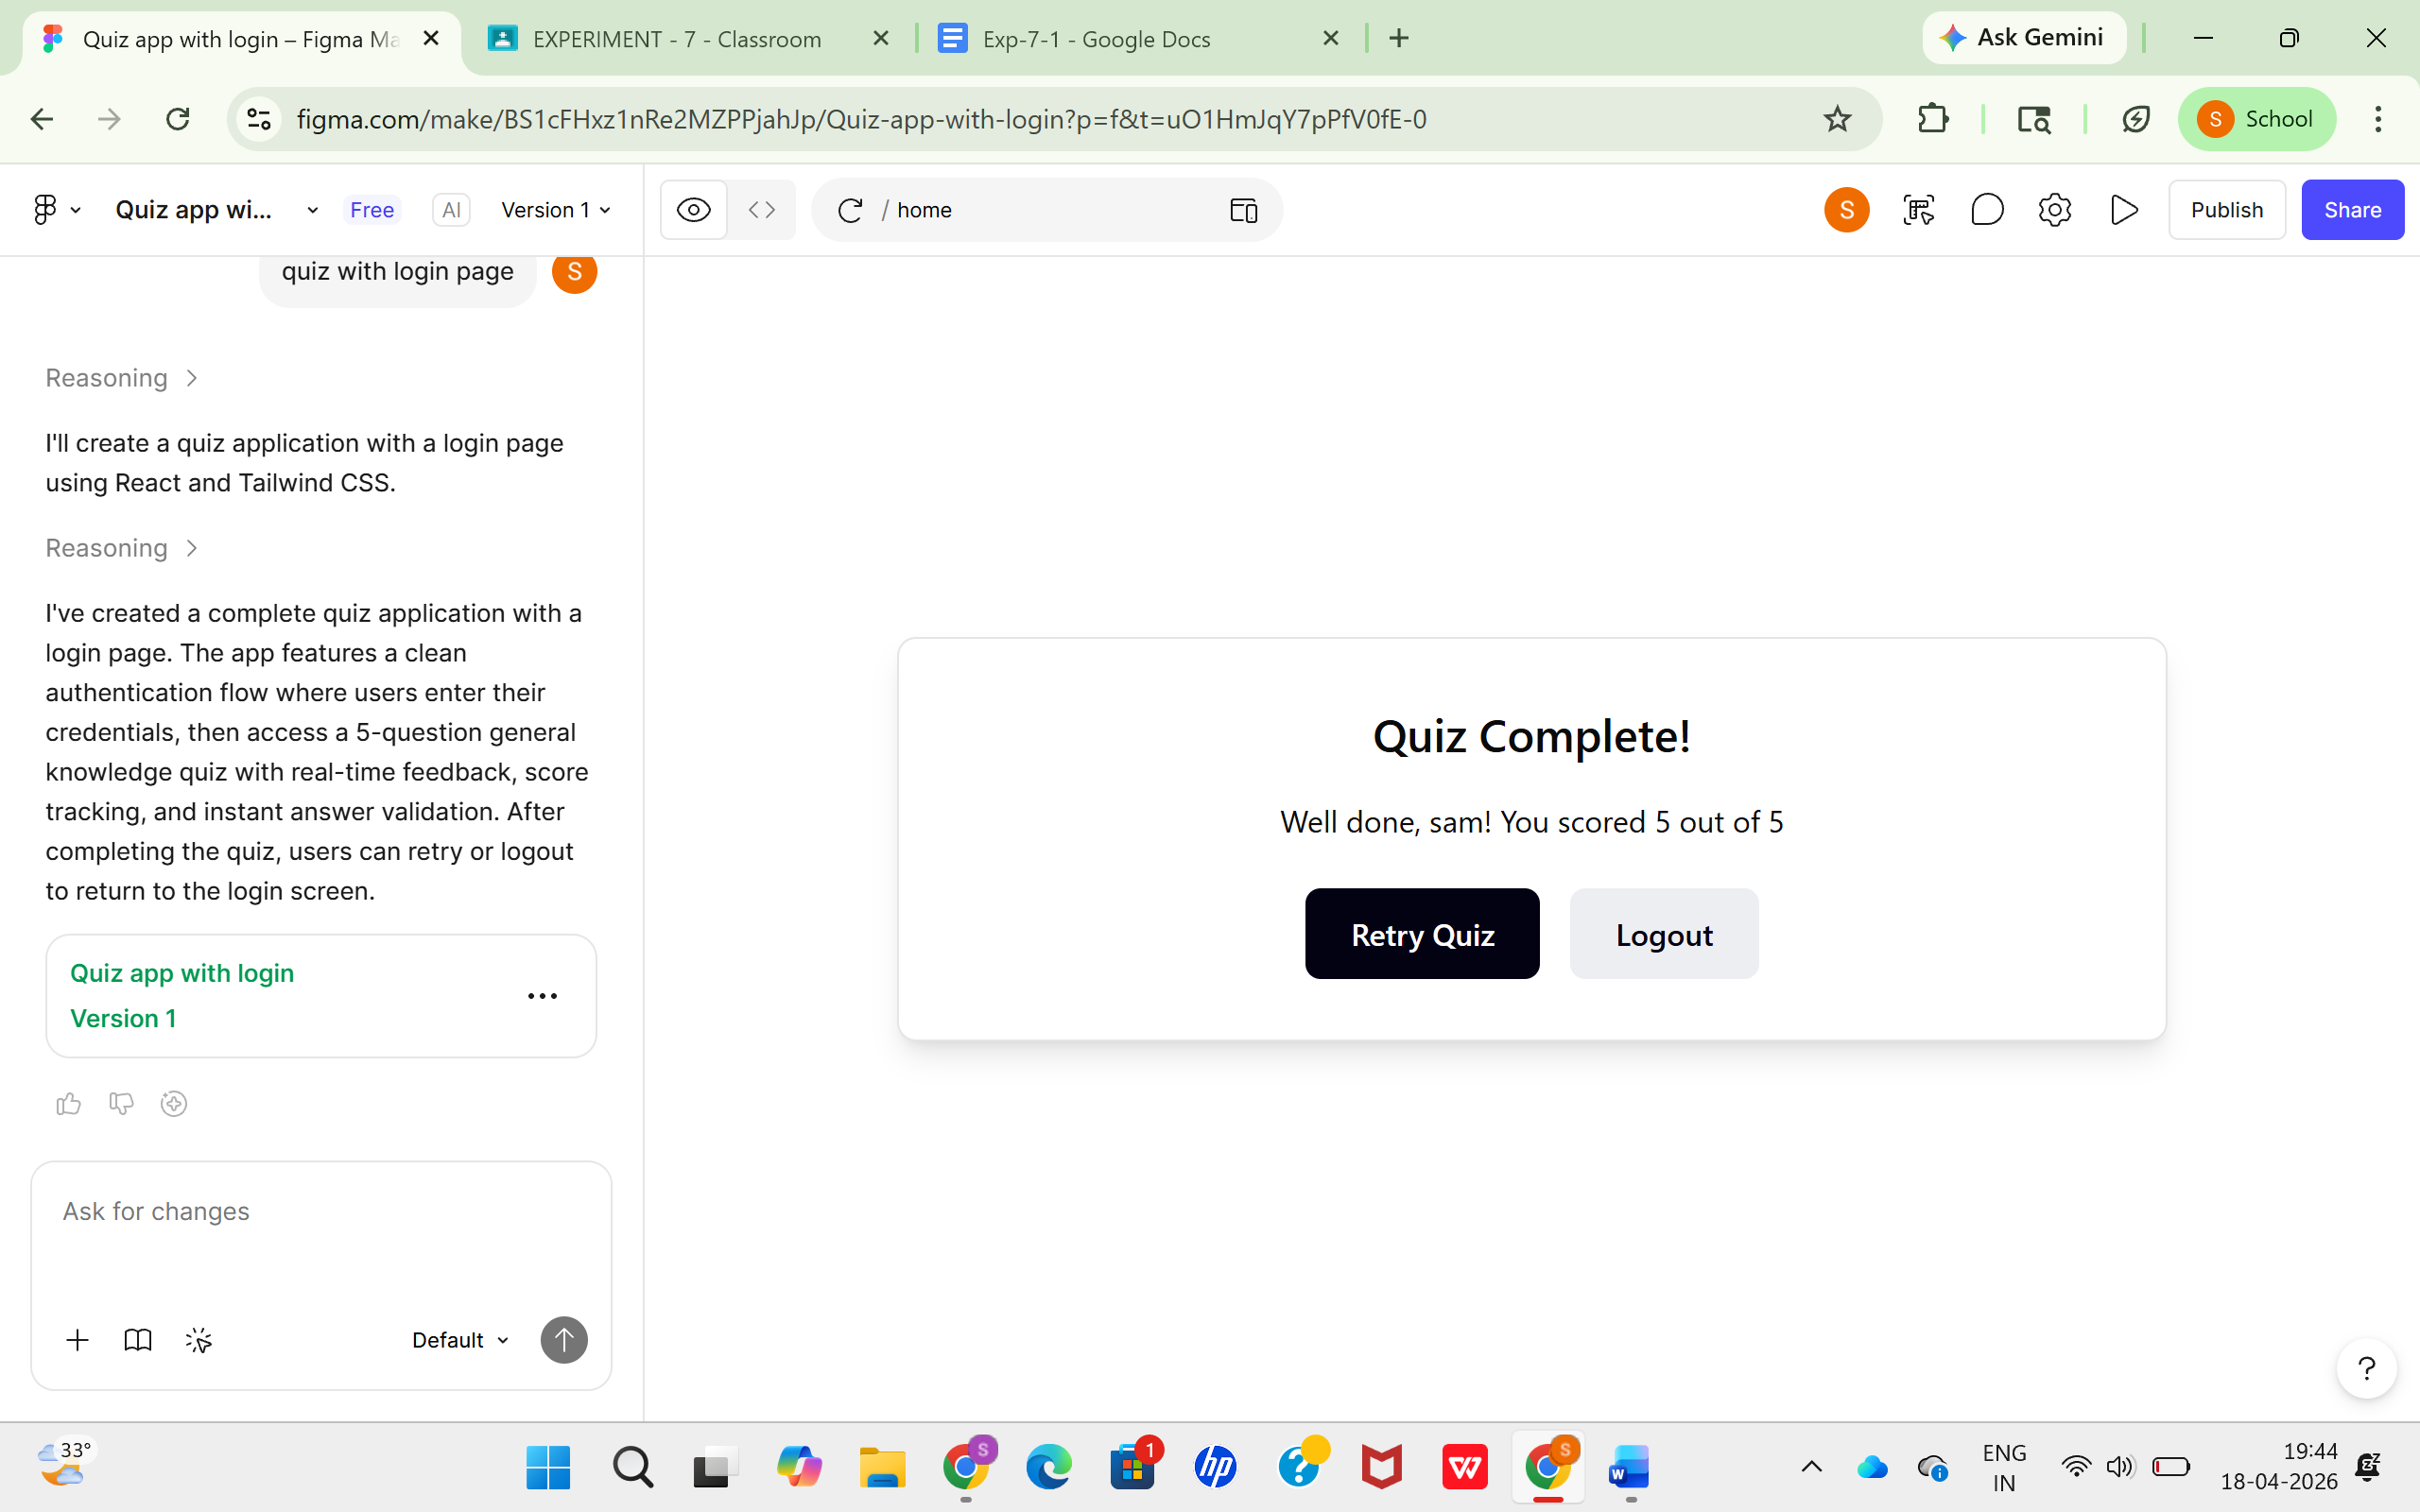

Result
The experiment successfully demonstrated that:
- A minimal and centered layout provides better usability.
- High contrast color schemes improve readability.
- User feedback helps refine UI design for better user experience.

